**UPDATING VACATIONS IN QGENDA**



**Phone app INSTRUCTIONS:**

1. Qgenda phone app.
2. Click on “Home” tab.
3. Click on the vacation dates that you are leaving behind. Make sure you select the correct date range.  (in this eg. ak is changing her existing 10/17 vacation day to a fictious approved vacation day of 11/5).
4. Click on “request to remove”.
5. Check the details.



1. Click “submit” as shown in the next 2 screenshots.
2. Click on “request” tab.
3. Date ranges.
4. In assignment notes pls indicate which schedule version shows the new vacation week eg below indicates version#19 displays the fake vacation day approve by dwl.
5. Click submit.

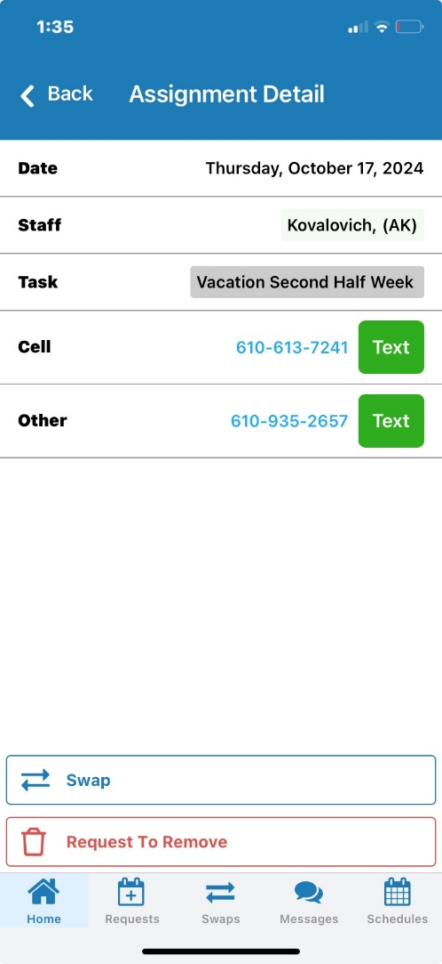



**DESKTOP APP INSTRUCTIONS:**

Step1:

Click on request tab.

Click on “x” for each day you are exiting.

Step 2:

Request tab.

Submit new request for the new vacation dates.

