ULTRASOUND EVALUATION OF THE FETAL HEART
Shi-Joon Yoo, MD, FRCPC, Edgar Jaeggi, MD
Introduction
Congenital Heart Diseases
Sonographic Technique, Basic Standard Views, and Anatomy
Imaging Technique and Normal Anatomy
Clues to the Abnormalities
Transverse View of the Upper Abdomen
Four-Chamber View
Ventricular Disproportion
Atrial, AV, and Ventricular Septal Defects
Three-Vessel View
Left and Right Ventricular Outflow Tract Views
Transposition of the Great Arteries
Single and Double Outlet Ventricle
Basal Short-Axis View
Aortic and Ductal Arch Views
Prenatal and Postnatal Treatment Options and Outcomes of Congenital Heart Diseases
Cardiac Tumors
Cardiac Rhythm
Normal Fetal Cardiac Rhythm
Sonographic Techniques for Cardiac Rhythm Assessement
M Mode Echocardiography
Pulsed Wave Doppler
Other Noninvasive Methods
Abnormal Cardiac Rhythms
Irregular Cardiac Rhythm
Bradycardia
Tachycardia
Examination for Pregnant Women with Anti-Ro/SSA and Anti-La/SSB Antibodies
Cardiac Function
Physiology of the Fetal Cardiovascular System
Cardiac Cycle
Techniques for Cardiac Functional Assessment
Shortening Fraction
Cardiac Output
Diastolic Function
Myocardial Performance Index
Abnormal Cardiac Function
INTRODUCTION
Prenatal ultrasound for detection of fetal anomalies has become a routine part of the pregnancy management in most advanced countries. Fetal cardiac examination is an indispensable part of the prenatal ultrasound because of the following well-recognized reasons. First, congenital heart diseases (CHDs) are common congenital anomalies. The incidence of moderate to severe forms of CHD is about 6/1000 live births.1 The incidence increases to 75/1000 live births if all mild lesions, such as bicuspid aortic valve and tiny muscular ventricular septal defects are included. The prenatal incidence of CHD is much higher with a tendency for an excess of complex lesions. Second, CHD is frequently associated with other noncardiac anomalies and chromosomal abnormalities.2–4 Extracardiac anomalies are found in 8% to 42% of patients with CHD. The incidence of chromosomal abnormalities ranges from 5% to 13% in live births with CHD2,3,5 and 15% to 50% in prenatal series.6–8 More than 50% of fetuses with abnormal chromosomes have cardiac anomalies. Nonchromosomal syndromes and associations comprise 1% to 5% of patients with CHD.3 Therefore, the presence of a congenital cardiac defect is an indication for chromosomal study and detailed ultrasound assessment of the extracardiac structures. Third, CHD is associated with significant neonatal and childhood morbidity and mortality. Approximately one quarter of all infant deaths are due to congenital malformations and one third of these deaths are related to CHD.9,10 CHD is the leading cause of neonatal and childhood deaths, not only because of the complexity of the malformations but also due to its high incidence. Prenatal diagnosis of significant CHD has a positive impact on the postnatal management with reduced surgical delays, shorter intensive care unit stays, and avoidance of severe hemodynamic compromise. Some cardiac lesions, such as complete transposition of the great arteries, require delivery at a tertiary care center for urgent postnatal management. A few congenital cardiac abnormalities, such as atrial flutter, bradycardia with atrioventricular block, critical aortic stenosis, and critical pulmonary stenosis, require in utero medication or intervention.11–14 Fourth, despite efforts to improve prenatal anomaly detection by introducing structured educational programs with basic ultrasound recommendations, cardiac anomalies continue to be overlooked and a huge variation in detection rates persists between geographic areas and centers.15–17
Fetal cardiac examination is performed either as a part of screening fetal sonography for a low-risk population or as a complete diagnostic test for groups at high risk for CHD (Table 14-1). The majority of the babies with CHD are born to parents with no identifiable risk factors. Therefore, the rate of detection of CHD depends largely on the sensitivity of the prenatal screening ultrasound. The earlier trials for fetal cardiac screening relied on a four-chamber view alone.18,19 However, this approach has proved inadequate for detection of abnormalities of visceral and atrial situs, the ventricular outflow tracts, and great arteries.20,21 Therefore, the screening examination should be extended to include the views for situs determination as well as the views for assessment of the ventricular outflow tracts and great arteries.22–24 Because the extended examination is rather extensive and complex, a well-standardized protocol should be set in order to reduce the examination time, while maintaining a high degree of diagnostic accuracy.
Table 14-1 High-risk Groups for Congenital Heart Disease
Fetal Risk Factors | Maternal Risk Factors | Familial Risk Factors
Chromosomal abnormality  Extracardiac anomaly  Omphalocele  Esophageal atresia  Duodenal atresia  Diaphragmatic hernia  VACTERL association  Increased nuchal translucency  Nuchal fold thickening  Nonimmune hydrops  Polyhydramnios  Oligohydramnios  Fetal cardiac dysrhythmia | Maternal disease  Congenital heart disease  Diabetes  Collagen vascular disease  Anti-Ra/Lo antibody positive  Phenylketonuria  Exposure to drugs, teratogens, or infections  Alcohol  Anticonvulsants  Lithium  Retinoic acid  Rubella, Coxsackie,  Cytomegalovirus  Parvovirus B19 | Family history of congenital heart disease  Siblings  Parents  Family history of syndromes associated with congenital heart disease  Tuberous sclerosis  Noonan syndrome  Holt-Oram syndrome  Chromosome 22q11 deletion
VACTERL, Vertebral, Anal, Cardiac, TracheoEsophageal, Renal and Radial, and Limb abnormalities.
Fetal cardiac examination should be performed when adequate images can be obtained for diagnosis in the majority of routine patients. The ideal timing is a compromise between examining sufficiently late not to miss late-developing lesions, and yet offering the diagnosis as early as possible for patients to have additional testing, including chromosomal study and to consider the options, if any, applicable to their particular diagnosis.25 The fetal heart can be visualized transvaginally as early as 9 weeks of gestation and abdominally by 11 weeks.26 Fetal echocardiography, using both transvaginal and transabdominal approaches, at or before 16 weeks of gestation on fetuses at risk of CHD, allowed distinction between a normal and abnormal cardiac appearance in the majority of cases.27,28 However, the earlier scan is technically more difficult and less accurate than the second trimester scan, whereas some forms of cardiac malformations do not become evident in the early period of pregnancy. As a result, some of the late-developing lesions may go undetected during early evaluation.25,29,30 Therefore, fetal cardiac examination is usually performed at 18 to 22 weeks of gestation in the countries where the legal limit of termination of pregnancy is 24 weeks. The earlier scan is justifiably applicable for patients at increased risk of congenital anomalies.25,26
Fetal cardiac examination requires a high-resolution ultrasound system with color and power Doppler, pulsed and continuous wave spectral Doppler and M-mode capabilities. The transducer is chosen according to the gestational age, the size of the mother, and the amount of amniotic fluid. Usually a 5- to 7.5-MHz convex or sector transducer is adequate for the 15- to 30-week scans. A 3-MHz transducer can be required for an obese mother or when there is polyhydramnios. A 3-MHz transducer may also be required after the late second trimester. In general, it is preferable to use a transducer with the highest possible frequency. It is essential to record the real-time images on a digital storage system.
The major part of the screening fetal cardiac examination is real-time grey-scale imaging of the cardiac and major vascular structures with color Doppler interrogation of the ventricular inlets and outflow tracts, and great arteries. Identification and assessment of the vascular anatomy can be further facilitated by power Doppler technique.
Three-dimensional ultrasound has become available for fetal imaging. Its applications to fetal facial and musculoskeletal abnormalities have been well established. It has also been proven very useful for fetal cardiac examination (Fig. 14-1).31–33 Following the acquisition of the volume dataset, the images are reconstructed offline in any desired planes. The image reconstruction enables the examiner to evaluate series of two-dimensional images in multiple views, evaluate intracardiac anatomy at different depth planes, and recreate casts of blood flow of the chambers and great vessels. This new technology not only enhances the ability of the examiner to identify normal and complex fetal heart anatomy but also facilitates routine image data acquisition by inexperienced personnel. Recent technology allows real-time three-dimensional or four-dimensional ultrasound for instantaneous acquisition of the volume data of the whole heart.
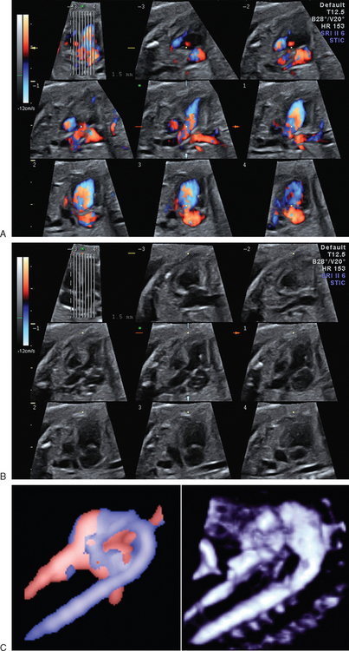
FIGURE 14-1 Three-dimensional echocardiograms obtained by spatiotemporal image correlation technique. A. Color Doppler spatiotemporal image correlation images. The left upper image is a five-chamber view showing the line cursors for oblique sagittal reformation. The oblique sagittal images are parallel slices that are orthogonal to the plane of the left upper image. B. Gray-scale images. Color signal is deleted from the images shown in A. C. Three-dimensional volume-rendered images from color and power Doppler data.
This chapter is divided into four parts according to the pathology and purposes of examinations: Part I, Congenital Heart Diseases; Part II, Cardiac Tumors; Part III, Cardiac Rhythm; Part IV, Cardiac Function.
Each part discusses the sonographic techniques, basic standard views and essential anatomy, the clues to the abnormalities, and the prenatal and postnatal treatment options and outcomes.
CONGENITAL HEART DISEASES
Sonographic Technique, Basic Standard Views, and Anatomy
For structural evaluation, the heart is assessed in a step-by-step fashion using sequential segmental analysis.34,35 In this approach, the heart is considered to consist of three segments: the atria, the ventricles, and the great arteries, and two connectors: the atrioventricular (AV)junction and the ventriculoarterial junction (Fig. 14-2). The key steps of the sequential segmental approach include (Fig. 14-3)
1. Determination of the visceral situs and position of the heart.
2. Identification of the morphologies of each component of each segment.
3. Assessment of the spatial relationships between the components of each segment.
a. Atrial relationship or situs
b. Ventricular relationship
c. Great arterial relationship
4. Determination of the connections between the segments at the AV and ventriculoarterial junctions.
a. AV connection
b. Ventriculoarterial connection
5. Evaluation of the associated malformation at each cardiac segment.
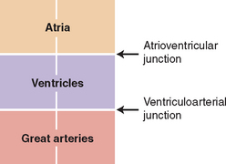
FIGURE 14-2 Basic cardiac segments and junctions.
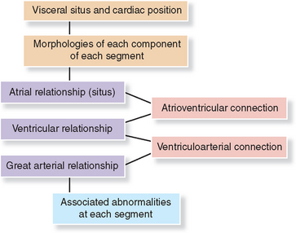
FIGURE 14-3 Steps of sequential segmental approach to congenital heart disease.
Sequential segmental approach can be achieved by continuous sweeping of the sonographic probe from the upper abdomen to the superior mediastinum in the orthogonal planes to the fetal body axis and along the long- and short-axis planes of the heart. In making a journey through the fetal heart and great vessels, the following landmark views should be obtained as the standard views for the complete anatomical assessment (Fig. 14-4)
1. Transverse view of the upper abdomen.
2. Four-chamber view.
3. Three-vessel view.
4. Left ventricular outflow tract view.
5. Right ventricular outflow tract view.
6. Basal short-axis view.
7. Aortic arch view.
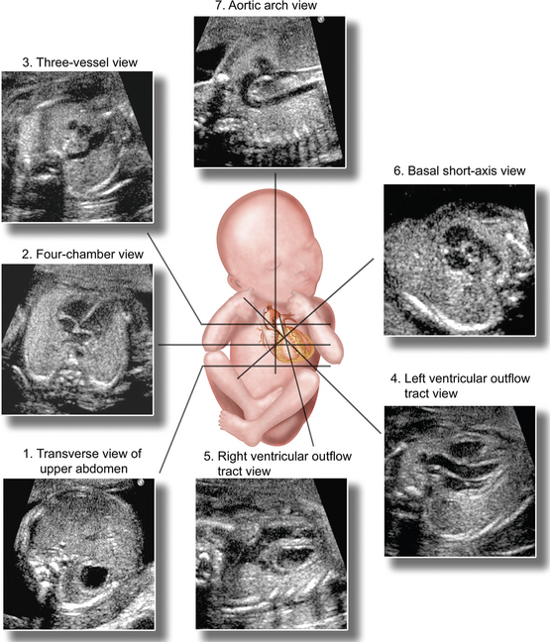
FIGURE 14-4 Basic sonographic views for fetal cardiac examination.
(Illustration by Shi-Joon Yoo, MD, and James A. Cooper, MD.)
Imaging Technique and Normal Anatomy
Fetal cardiac examination should begin with determination of the position and orientation of the fetus relative to the long axis of the mother and identification of the right and left sides of the fetus. This step can be quickly performed by sweeping the transducer in the transverse and longitudinal planes of the maternal body. It is essential not to determine the right and left sides of the fetus according to the position of the stomach because it can be on the wrong side. For the beginners, a doll can be positioned on the maternal abdomen to facilitate this step.
Once the right and left sides of the fetus are defined, the transverse view of the upper abdomen is obtained for the determination of the visceral situs, which is the first step of sequential segmental analysis (see Fig. 14-4).34 It is strongly advised not to start the cardiac examination with the heart. The transverse view of the upper abdomen is the view that is used for the measurement of the abdominal circumference. In this view, the larger lobe of the liver and gallbladder are on the right, and the stomach on the left (Fig. 14-5). The cross-section of the abdominal aorta is at the left anterior corner of the spine, whereas the cross-section of the inferior vena cava is on the right. The inferior vena cava is an anterior structure compared with the aorta because it courses forward as it connects to the right atrium. In a well-taken image, a sickle-shaped spleen can be seen behind the stomach.
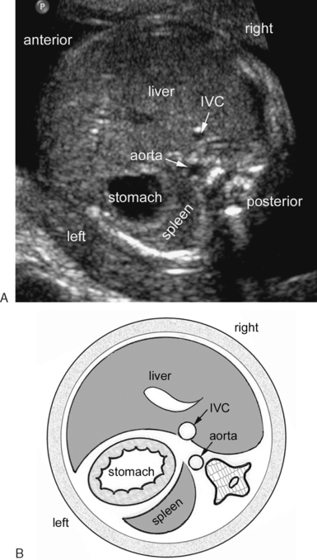
FIGURE 14-5 Transverse view of the upper abdomen (A) and corresponding diagram (B). The larger lobe of the liver is on the right, and the stomach on the left. The descending aorta (ao) is at the left anterior aspect of the spine. The inferior vena cava (IVC) is on the right side of the midline. Note that the inferior vena cava is located anteriorly at some distance from the spine as it courses forward to connect to the right atrium above this level.
The transducer is then moved, along the long axis of the fetal body, toward the fetal head to obtain a four-chamber view (see Fig. 14-4).18,19 Because the transducer is swept from the upper abdomen to the four-chamber plane, it is important to follow the inferior vena cava connecting to the right atrium. In the four-chamber view, the heart occupies approximately one third of the thoracic area and the cardiac axis is directed 45 ± 20 degrees leftward from the coronal or sagittal plane (Fig. 14-6).36,37 In the first and second trimesters, the cardiac chambers seen in the four-chamber view are symmetric in size. The right atrium and ventricle become slightly larger than the left atrium and ventricle in the third trimester.38,39 The septum between the four chambers of the heart consists of three parts: atrial, AV, and ventricular (see Fig. 14-6B, C). The AV septum is present between the right atrium and left ventricle because the tricuspid valve has a more apical attachment to the septum than the mitral valve.40 The central part of the atrial septum is the thin and mobile primum septum (see Fig. 14-6C). In the normal fetus, this part of the septum bulges toward the left atrium as the blood flows from the right atrium into the left atrium through the foramen ovale. The pulmonary veins are identifiable in the four-chamber view. Color and power Doppler techniques are helpful in identifying the pulmonary veins (see Fig. 14-6E). When color Doppler is used for identification of the pulmonary veins, the velocity setting should be set at less than 30 cm/second. Usually, the pulmonary veins that are seen in the four-chamber view are the lower veins, which course slightly forward as they connect to the left atrium. The upper pulmonary veins are more superior and anterior as compared with the lower veins and, therefore, are not shown in the regular four-chamber view. The lowest section through the four chambers shows the coronary sinus as a small tubular structure between the left ventricle and the orifice of the inferior vena cava (see Fig. 14-6F).41 In the apical part of the right ventricle, a muscle bundle called ‘the moderator band’ crosses the cavity. It may be seen as a muscle bundle extending from the septum to the parietal wall (see Fig. 14-6B), but is more often seen as a muscle mass obliterating the apical part of the cavity (see Fig. 14-6A and C). The septal attachment of the AV valves and the presence of the moderator band are the two most important morphologic criteria for ventricular identification. On the other hand, differences in trabeculation pattern between the right and left ventricles are hardly recognizable on the fetal ultrasound examination. The function of the tricuspid and mitral valves should be assessed using color Doppler with a velocity set at 60 to 80 cm/second (see Fig. 14-6G). Trivial tricuspid regurgitation is not uncommon and is usually transient (see Fig. 14-6H).42,43 A recent study using three-dimensional color Doppler technique showed mild-to-moderate tricuspid regurgitation in 83% of fetuses in the early second trimester.43 However, substantial tricuspid regurgitation in the first trimester is frequently a marker of cardiac malformations or chromosomal defects in the absence of structural heart disease.44–46 The cross-section of the descending aorta is seen behind the heart at the left anterior aspect of the vertebral body. The cross-section of the esophagus can occasionally be seen as an echolucent structure adjacent to the aorta when the fetus swallows amniotic fluid. In contrast to the vascular structures, the esophagus barely demonstrates signal using color or power Doppler, and disappears and reappears in a few seconds or minutes.
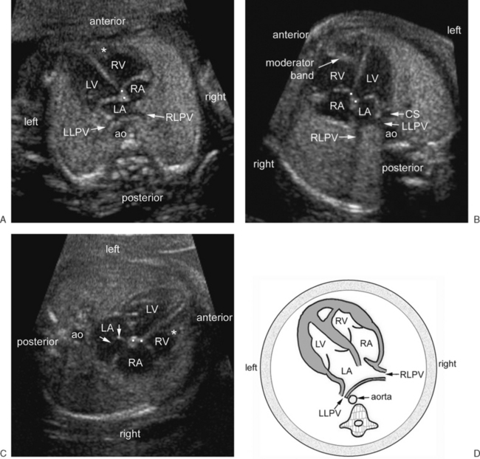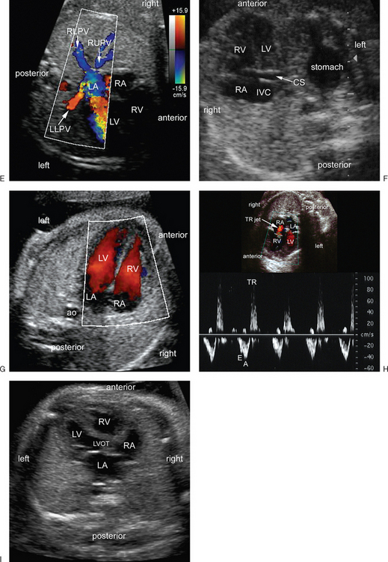
FIGURE 14-6 Four-chamber and five-chamber views (A–D). Three different four-chamber views and diagram (D). The right- and left-sided chambers are symmetric in size. The atrioventricular valves have offset attachments (dots in A–C) to the septum with the tricuspid valve having more apical attachment than the mitral valve. The apex of the right ventricle (RV) is obliterated in A and C by the moderator band (asterisk). The moderator band can also be seen as a distinct muscle bundle as shown in B. Right and left lower pulmonary veins (RLPV and LLPV) course obliquely forward as they connect to the left atrium (LA). The central part of the atrial septum is the septum primum (arrows in C). It is thin and mobile, and bulges into the left atrium. The descending aorta (ao) is seen at the left anterior corner of the spine. E. Color Doppler image in four-chamber plane showing both lower pulmonary veins and the right upper pulmonary vein (RUPV). Both lower pulmonary veins course obliquely forward, whereas the right upper pulmonary vein courses obliquely backward as it connects to the left atrium. F. A lower section below the four-chamber view. The coronary sinus (CS) is seen as a tubular structure between the left ventricle (LV) and the inferior vena caval orifice (IVC). Note that its proximal part of the coronary sinus can be seen as a small round circle at the left atrioventricular junction in a regular four-chamber view as shown in B. G. Color Doppler image shows flow through the atrioventricular valves. H. Color Doppler image and Doppler spectrum show trivial tricuspid regurgitation (TR). E and A are the early and late diastolic peaks of the tricuspid inflow, respectively. I. Five-chamber view. A section slightly cranial to the regular four-chamber shows the left ventricular outflow tract (LVOT). RA, right atrium.
From the four-chamber plane, the transducer is moved upward along the long axis of the fetal body. The four-chamber view changes into a ‘five-chamber view’ in which the aortic valve is seen to arise from the left ventricular outflow tract in the center of the four chambers (see Fig. 14-6I). Further upward movement of the transducer creates a three-vessel view in which the oblique section of the main pulmonary artery and cross-sections of the ascending aorta and superior vena cava (SVC) are seen (see Figs. 14-4 and 14-7).47,48 The three vessels are arranged in a straight line from the left anterior to the right posterior aspect of the mediastinum with a decreasing order of the size. In the adjacent planes shown by slight downward or upward movement or angulation of the transducer, the right and left pulmonary arteries, and the ductal and aortic arches are visualized. In fact, there are three arches in the upper mediastinum; the ductal, aortic, and azygos venous arches (see Fig. 14-7C, F, and G). In addition, the trachea and the major bronchi are identifiable because they contain fluid in fetal life (see Fig. 14-7B, D, and G). Therefore, the position of the aortic arch relative to the trachea can be well defined. Normally, the aortic arch is a sausage-like structure coursing obliquely from right anterior to left posterior on the left side of the trachea. To emphasize the presence of the trachea in the three-vessel view, the term three vessels and trachea view has been suggested.49,50 The aortic and ductal arches make a V-shaped confluence at the descending aorta (see Fig. 14-7C and F). In the V-view, the ductal arch is slightly bigger than the aortic arch. After it arises from the main pulmonary artery, the right pulmonary artery takes a long horizontal course in front of the tracheal bifurcation before it reaches the right lung hilum (see Fig. 14-7). On the contrary, the left pulmonary artery courses obliquely backward and leftward to reach the left lung hilum. Also seen in the transverse view of the upper mediastinum at the level of the aortic arch is the innominate vein coursing horizontally in front of the ascending aorta. The identification of the various vascular structures in the upper mediastinum can be facilitated with color and power Doppler interrogation. However, the vessel sizes should not be measured by color or power Doppler as the vessels look significantly bigger because of the blooming effect. Anterior to the three vessels, the thymus is seen as an area of different echogenecity as compared with the lungs (see Fig. 14-7G).51–53 Its echogenecity is similar to or slightly more than that of the adjacent lungs in the early second trimester and it becomes less echogenic in later pregnancy. It typically contains spindle-shaped echogenic spots that make its differentiation from the lungs possible. Its transverse diameter in millimeters is slightly smaller than the gestational age in weeks in the second trimester and becomes slightly larger as the pregnancy approaches the term.54
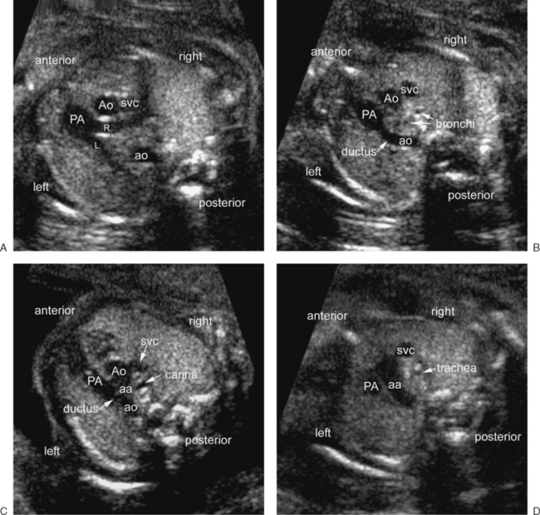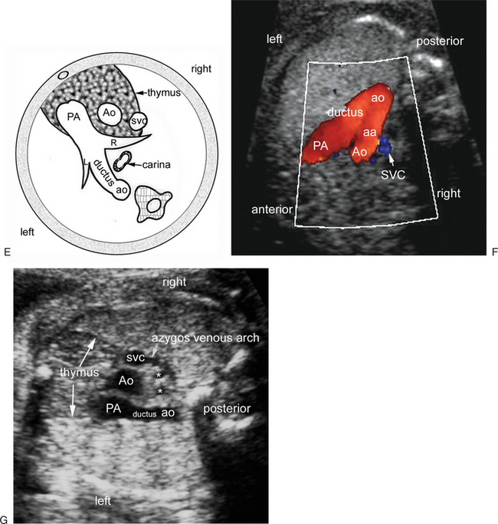
FIGURE 14-7 Three-vessel view and its vicinity. A–E. Serial transverse views of the upper mediastinum and a diagram (E) showing the anatomy of the three-vessel view. In its most basal cut (A), the main pulmonary artery (PA) branches into the right (R) and left (L) pulmonary arteries. Above this level (B), where the main pulmonary artery continues to the descending aorta (ao) through the ductus arteriosus, the following three vessels: the main pulmonary artery, the ascending aorta (Ao) and superior vena cava (svc) are aligned in a straight line from the left anterior aspect to the right posterior aspect of the thorax. The three vessels are sized in a decreasing order with the main pulmonary artery being the largest and the superior vena cava the smallest. The right and left bronchi, filled with fluid, are seen in the middle mediastinum. Immediately above this (C), the aortic arch (aa) and ductus arteriosus form a V-shaped confluence at the descending aorta on the left side of the carina of the trachea. In the most cranial level of the three vessels (D), the sausage-shaped aortic arch is seen on the left side of the trachea. F. Color Doppler image in three-vessel plane shows a V-shaped confluence of the aortic arch and ductus arteriosus at the descending aorta. G. Three-vessel view taken from the right side of the fetus shows the thymus demarcated by thin echogenic lines. The echogenecity of the thymus is slightly different from the adjacent lungs. The thymus contains spindle-shaped echogenic spots. Note the azygos venous arch on the right side. Asterisks are right and left main bronchi.
The ventricular outflow tract views need special maneuvers (Fig. 14-8).23,55 The transducer is moved back to a four-chamber plane. Then the transducer is moved around the fetal thorax until the sonographic beam is positioned perpendicular to the ventricular septum. This procedure aligns the ventricular septum horizontally in the image. In this particular position, the left ventricular outflow tract view can be obtained simply by rotating the transducer 20 to 30 degrees clockwise or counterclockwise toward the cardiac apex. By sliding the transducer upward toward the fetal head from this plane, the right ventricular outflow tract view can be obtained. By moving the transducer slightly up and down along the fetal thorax, the crossing nature of the ventricular outflow tracts can be clearly appreciated. Occasionally, the ventricular septum is hard to place perpendicular to the sonographic beam. In this situation, the transducer is positioned to the apex of the heart and then angled cranially toward the fetal head so that the sonographic beam is aligned parallel with the long axis of the heart. This latter maneuver, however, is more difficult than the former. The left ventricular outflow tract view demonstrates not only the left ventricular outflow tract but also the left ventricular inlet, with the anterior leaflet of the mitral valve demarcating the two (see Fig. 14-8B toD). The aortic valve is in direct contact with the mitral valve, and therefore, the left ventricular outflow tract is not completely muscular. This is in contrast to the right ventricle, in which there is discontinuity between the pulmonary and tricuspid valves because of the presence of an intervening muscular crest that is called crista supraventricularis or ventriculoinfundibular fold. Therefore, the right ventricular outflow tract is a completely muscular tunnel. The ventricular septum seen in the left ventricular outflow tract view is the more anterior part of the ventricular septum as compared with the septum seen in the four-chamber view. The part of the ventricular septum that abuts the aortic valve is the membranous septum, which is most commonly involved in ventricular septal defects. Commonly, this area of the septum normally appears defective because the septum has a curved configuration and the septum below the aortic valve is the thin membranous part, which makes the diagnosis of a small ventricular septal defect in this region very difficult. In the right ventricular outflow tract view, the right ventricular outflow tract leads to the main pulmonary artery upward and backward (see Fig. 14-8E to G). This is in contrast with the left ventricular outflow tract that courses upward and forward. In the left and right ventricular outflow tract views, the blood flow across the aortic and pulmonary valves should be assessed by using color Doppler with a velocity set at 80 to 100 cm/sec (see Fig. 14-8C and F).
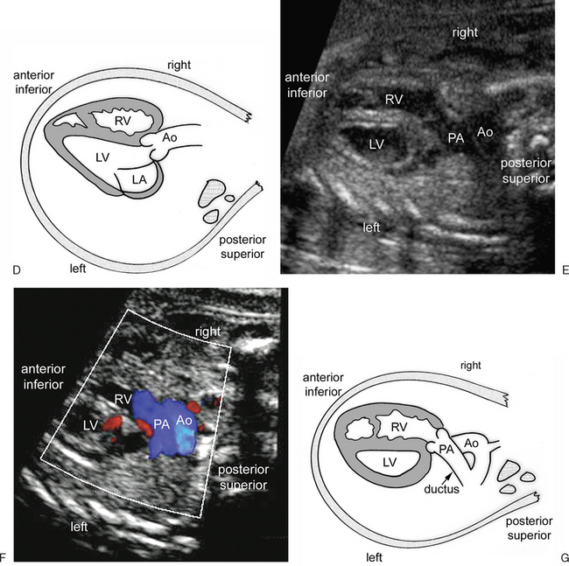
FIGURE 14-8 Left and right ventricular outflow tract views. A. Composite diagram showing how the ventricular outflow tract views are obtained in a fetus in supine cephalic presentation. The scan starts from any transducer position for a four-chamber view (panel a). In step I, the transducer is moved around the fetal chest until the ventricular septum is seen horizontally in the four-chamber view (panel b). In step II, the transducer is rotated 20 to 30 degrees (clockwise in this example with a fetus laying in supine cephalic presentation) towards the cardiac apex until the left ventricular outflow tract view (panel c) is shown. In step III, the transducer is moved upward towards the fetal head until the right ventricular outflow tract view (panel d) is shown. B–D. Left ventricular outflow tract views and diagram. Both the inlet and outlet of the left ventricle (LV) are seen. The anterior leaflet of the mitral valve is the anterior border of the left ventricular inlet in diastole, and the posterior border of the left ventricular outlet during systole. The aortic and mitral valves are in direct contact (asterisk). The left ventricular outflow tract courses upward and slightly forward. E–G. Right ventricular outflow tract views and diagram. The right ventricular (RV) outflow tract leads to the main pulmonary artery (PA) upward and backward. Note the crossing nature of the ventricular outflow tracts to the arterial trunks by comparing the left and right ventricular outflow tract views. Ao, ascending aorta; ao, descending aorta; LA, left atrium; RA, right atrium.
(Modified with permission from Yoo SJ, Lee YH, Kim ES, et al: Tetralogy of Fallot in the fetus: Findings at targeted sonography. Ultrasound Obstet Gynecol 14:29, 1999.)
The basal short-axis view is rather difficult to obtain. This view is an oblique view through the right lobe of the liver and the left shoulder (see Figs. 14-4 and 14-9). When an oblique section through these two structures is obtained, the transducer is angled up and down until the cross-sectioned aortic valve is encircled by the right atrium, right ventricle, main pulmonary artery, and right pulmonary artery. This view clearly shows the discontinuity between the tricuspid and pulmonary valves due to the crista supraventricularis or ventriculoinfundibular fold separating the two valves (asterisks in Fig. 14-9A). This view is best for assessing patency of the right ventricular outflow tract. As seen in the left ventricular outflow tract view, the part of the septum abutting the tricuspid valve is the membranous septum and, therefore, may appear defective. After the main pulmonary artery bifurcates into the right and left pulmonary arteries, the right pulmonary artery courses rightward along the posterior wall of the aortic valve, whereas the left pulmonary artery continues to the descending aorta through the ductus arteriosus. A different but equivalent anatomy can be seen in right anterior oblique long axis view of the right ventricle (see Fig. 14-9D). This view visualizes the three components of the right ventricle, namely the inlet, trabecular, and outlet parts. The three vessels are also visualized in their oblique or longitudinal sections.
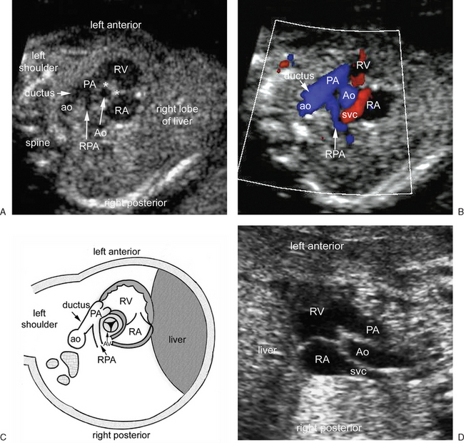
FIGURE 14-9 Basal short-axis view and an alternative view. A–C. Basal-short axis views and diagram. The cross-section of the aortic valve (AV) or the ascending aortic root (Ao) is encircled by the right atrium (RA), right ventricle (RV), main pulmonary artery (PA) and right pulmonary artery (RPA). Note the discontinuity between the tricuspid and pulmonary valve annuli (asterisks). The right ventricular outflow tract is widely open. The main pulmonary artery connects to the descending aorta (ao) through the ductus arteriosus. (D) Right anterior oblique view of the right ventricle. This view is equivalent to the x-ray angiographic right anterior oblique view. The three components of the right ventricle, the inlet, apical trabecular, and outlet parts are well shown. The three vessels–the main pulmonary artery, the ascending aorta, and the superior vena cava (SVC)–are aligned as they are typically seen in the three-vessel view.
The aortic arch view can be obtained from a three-vessel view. The transducer is moved around the fetal thorax until the sonographic beam is aligned with the cross-sections of the ascending and descending aorta (Fig. 14-10).55,56 The cross-sections of the ascending and descending aorta are then seen vertically in the three-vessel view. In this position, the transducer is rotated 90 degrees in either clockwise or counterclockwise direction and the aortic arch is shown as a candy cane configuration. The ductal arch view can be obtained in a similar manner. The transducer is moved around the fetal thorax until the oblique section of the main pulmonary artery and the cross-section of the ascending aorta are aligned vertically in the three-vessel view. Then, the transducer is rotated 90 degrees in either direction and a hockey stick view of the ductal arch is produced. In the aortic arch view, the ascending aorta arises from the center of the heart between the right and left atria and, therefore, is some distance from the anterior chest wall. The aortic arch view shows the right innominate, left carotid, and left subclavian arteries arising from the greater curvature side of the arch. On the other hand, the ductal arch arises far anteriorly, immediately behind the anterior chest wall, as its proximal part is the main pulmonary artery. It takes a rather long course backward as it connects to the descending aorta through the ductus arteriosus. In contrast to the aortic arch, the ductal arch does not give rise to any branch to the head and neck. When the fetus is in either right or left lateral decubitus position, the candy cane and hockey stick views are not possible to obtain. Both arches are then assessed in transverse views (see Fig. 14-7B to F). In the later pregnancy, the ductus arteriosus may become tortuous and a faulty diagnosis of the aneurysm of the ductus arteriosus can be entertained (see Fig. 14-10F).
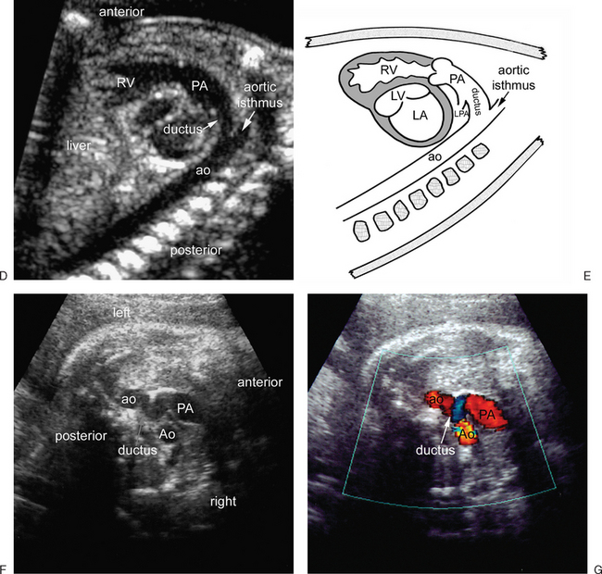
FIGURE 14-10 Aortic and ductal arch views. A. Composite diagram showing how the aortic and ductal arch views are obtained in a fetus in supine cephalic presentation. The scan starts from any transducer position for a three-vessel view (panel a). In step I, the transducer is moved around the fetal chest until the ascending aorta (Ao) and descending aorta (ao) are aligned vertically in the three-vessel view (panel b). In step II, the transducer is rotated 90 degrees either clockwise or counterclockwise until the aortic arch is seen as a candy cane-like structure (panel c). In step III, the transducer is moved back to a three-vessel view and moved around the fetal chest until the main pulmonary artery (PA) and the descending aorta (ao) are vertically aligned (panel a). In step IV, the transducer is rotated 90 degrees either clockwise or counterclockwise until the ductal arch is seen as a hockey stick-like structure (panel d). B and C. Aortic arch views and diagram. The aortic arch arises from the space between the right (RA) and left (LA) atria, and therefore, its origin is some distance away from the anterior chest wall. The aortic arch gives rise to the right innominate or brachiocephalic (RIA), left common carotid (LCA), and left subclavian (LSA) arteries. The cross-section of the innominate vein is seen in front of the right innominate artery. The cross-section of the right pulmonary artery (RPA) is seen immediately behind the ascending aorta. D and E. Ductal arch views and diagram. The ductus arteriosus connects the main pulmonary artery to the descending aorta, thus forming a hockey stick-shaped arch. As its proximal part is the main pulmonary artery, its origin is immediately behind the anterior chest wall. In contrast to the aortic arch, it does not give rise to any head and neck branches. F and G. Tortuous ductus arteriosus in a fetus at 35 weeks of gestation. The ductus arteriosus tends to become tortuous in later pregnancy. It can be mistaken for an aneurysm of the ductus arteriosus. Color Doppler image (G) shows a U-loop of the ductus arteriosus with blue and red signals. LPA, left pulmonary artery.
(Modified with permission from Yoo SJ, Lee YH, Kim ES, et al: Tetralogy of Fallot in the fetus: Findings at targeted sonography. Ultrasound Obstet Gynecol 14:29, 1999.)
Normal measurement data for cardiac and major vascular dimensions are listed in the appendix.
Clues to the Abnormalities
Table 14-2 lists the key anatomic structures that should be investigated and the clues to the presence of CHD at each screening view.
Table 14-2 Clues to the Abnormality at Each Sonographic View
Sonographic View | Structures to Investigate | Clues to Abnormalities
Transverse view of upper abdomen | Larger lobe of the liver  Stomach  Abdominal aorta  Inferior vena cava | Abnormal position of the stomach and liver  Absent or multiple spleens  Aorta and inferior vena cava on the same side of the spine  Interruption of the inferior vena cava
Four-chamber view | Position, size and axis of the heart  Size symmetry of cardiac chambers and great vessels  Pulmonary veins  Atrioventricular valve attachment and function  Moderator band  Septal integrity | Cardiac malposition  Displaced heart  Abnormal cardiac axis  Abnormal atrioventricular connections; discordant connection, univentricular connection  Cardiomegaly  Asymmetric chamber and valve size  Atrial, ventricular or atrioventricular septal defect  Apical displacement of the septal leaflet of the tricuspid valve  Abnormal pulmonary venous connections
Three-vessel view | Vessel number, alignment and size  Position and size of aortic and ductal arches  Trachea and bronchi  Branch pulmonary arteries | Dilatation of the aorta, pulmonary trunk or superior vena cava  Discrepancy in great arterial size  Abnormal vessel alignment  Abnormal vessel arrangement  Aortapulmonary window  Only two vessels  Additional vessel  Right descending aorta  Abnormal origin or course of a pulmonary artery  Ductal constriction or aneurysm  Small or absent thymus
Left and right ventricular outflow tract views | Crossing nature of outflow tracts to arterial trunks  Patency of outflow tracts and semilunar valves  Septal integrity | Abnormal ventriculoarterial connections: transposition, double outlet right or left ventricle; and single arterial trunk  Ventricular septal defect  Overriding aorta or pulmonary trunk  Abnormal dimension of the outflow tracts and/or arterial valves
Basal short-axis view | Crista supraventricularis  Sub pulmonary outflow tract  Size of aortic valve and left ventricular outflow tract | Ventricular septal defect in the outlet septum  Right ventricular outflow tract narrowing  Small size of the aortic valve
Aortic and ductal arch views | Position, contour and size of aortic and ductal arches  Patency of the aortic arch  Aortic arch branches | Ascending aorta smaller than descending aorta  Focal or diffuse narrowing of the aortic arch  Interruption of the aortic arch  Right aortic arch  Double aortic arch  Ductal constriction or aneurysm  Vessel behind the trachea
Transverse View of the Upper Abdomen
The transverse view of the upper abdomen provides the main information regarding whether the visceral situs is normal or abnormal, and if it is abnormal, the pattern of situs most likely present. This is important because situs abnormalities are harbingers of CHD (Tables 14-3 and 14-4).34,57–60
Table 14-3 Incidence of Congenital Heart Disease in Various Forms of Cardiac Malposition1,57–60
Visceral Situs and Heart Position | Incidence of Heart Defects
Situs solitus with levocardia (normal heart position) | <1%
Situs solitus with dextrocardia | >90%
Situs inversus with dextrocardia | 10%–50%
Situs inversus with levocardia | >95%
Heterotaxy with right isomerism | ∼100%
Heterotaxy with left isomerism | Majority
Table 14-4 Abnormal Findings at Transverse View of the Upper Abdomen
Abnormal Finding | Significance
Stomach on the right side | The body situs is abnormal
Mirror-image arrangement of the liver, stomach, inferior vena cava, and abdominal aorta | The situs is inverted.
Transverse liver | Either right isomerism or left isomerism. Left isomerism tends to show some asymmetry of the hepatic configuration.
Piggy-backed abdominal aorta behind the inferior vena cava on the same side of the spine (so-called juxtaposition) | Highly suggestive of right isomerism. The dilated azygos vein receiving the interrupted inferior vena cava can occasionally be seen on the same side of the spine but the aorta is the anterior vessel.
Interruption of the inferior vena cava | Occurs in 75%–90% of left isomerism and rarely in other types of body situs.
Multiple spleens or lobulated single spleen | Means polysplenia and occurs in left isomerism with few exceptions.
No identifiable spleen | Can be due to technical limitation but is typically seen in right isomerism with few exceptions.
The term visceral situs refers to the pattern of arrangement of the body organs relative to the midline or sagittal plane. There are three types of visceral situs: namely, situs solitus, situs inversus, and heterotaxy Fig. 14-11).58,61 The visceral situs can usually be determined by observing the location of the liver, stomach, abdominal aorta, and inferior vena cava as seen in the transverse view of the upper abdomen.
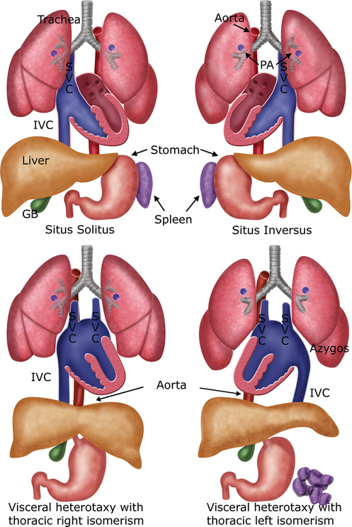
FIGURE 14-11 Types of visceral situs. GB, gallbladder; IVC, inferior vena cava; PA, branch pulmonary artery; SVC, superior vena cava.
(Illustration by Shi-Joon Yoo, MD, and James A. Cooper, MD.)
In situs solitus, the larger lobe of the liver and gall bladder are seen on the right and the stomach on the left (see Fig. 14-5). The spleen can be identified along the posterolateral wall of the stomach as a sickle-shaped structure. The abdominal aorta is located posteriorly at the left anterior aspect of the spine. The inferior vena cava is located more anteriorly on the right as it connects to the right-sided right atrium. In situs inversus, these right-left relationships are inverted (Fig. 14-12A). Situs inversus may escape detection if the right and left sides of the fetal body are not defined in the beginning of the fetal echocardiographic examination.
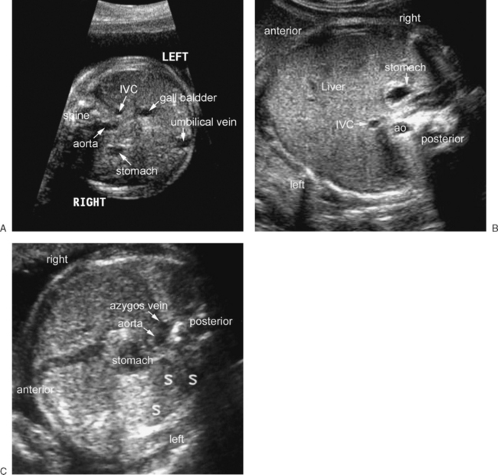
FIGURE 14-12 Transverse view of the upper abdomen in situs inversus (A), heterotaxy with asplenia (B), and heterotaxy with polysplenia (C). Situs inversus is characterized by mirror-image arrangement of the abdominal organs. B. The abdominal aorta is piggy-backed behind the inferior vena cava (IVC) on the same side of the spine. This juxtaposed position of the inferior vena cava and abdominal aorta is seen in more than 90% of right isomerism. The liver extends from one side of the abdomen to the other. In C, two vessels are seen along the anterior margin of the spine. They are obliquely aligned in front of the spine. The posterior vessel is the dilated azygos vein that drains the interrupted inferior vena cava, which is associated with left isomerism in 75% to 90% of cases. The two vessels can also be aligned side-by-side in front of the spine. Note the multiple spleens (S) along the greater curvature side of the stomach.
(C reprinted with permission from Yoo SJ, Lee YH, Cho KS, et al: Sequential segmental approach to fetal congenital heart disease. Cardiol Young 9:430, 1999.)
Heterotaxy (Greek, heteros [other than] + taxis [arrangement]) indicates an arrangement of the organs that is different from the orderly arrangement of either situs solitus or situs inversus (see Fig. 14-12B and C).61 Heterotaxy has often been called situs ambiguus, which means uncertain situs. However, ‘situs ambiguus’ is not an appropriate term, because the organ arrangement in heterotaxy is not uncertain but rather complex or hard to define.34 Abdominal heterotaxy is characterized by jumbled-up arrangement of the nonpaired organs. Heterotaxy is almost always associated with asplenia or polysplenia.57,58,62–68 Heterotaxy with asplenia is characterized by a symmetric liver extending from one side of the abdomen to the other with the stomach on either side (see Fig. 14-12B). In most cases of asplenia, the inferior vena cava and abdominal aorta are juxtaposed on the same side of the spine, with the former being located in front of the latter.62,64,67,69,70 Heterotaxy with polysplenia also shows an abnormally disposed liver with the stomach on either side (see Fig. 14-12C

